STATION 1

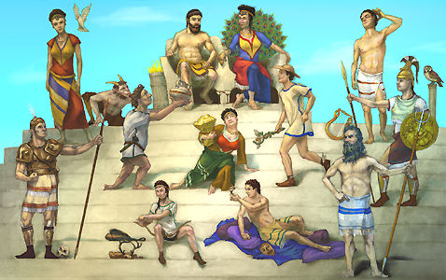

GREEK GODS & GODDESSES

- ACCESS THE FOLLOWING WEBSITE: http://www.theoi.com/greek-mythology/olympian-gods.html
- IDENTIFY THE 12 MOST INFLUENTIAL GODS AND GODDESSES & GIVE A SHORT (2-3 SENTENCES) DESCRIPTION OF EACH ON A SEPARATE SHEET OF PAPER.
- CHOOSE THE ONE YOUR GROUP MOST CLOSELY IDENTIFIES WITH AND EXPLAIN WHY, ON YOUR SHEET OF PAPER.

- APHRODITE
- APOLLO
- ARES
- ARTEMIS
- ATHENA
- DEMETER
- DIONYSUS
- HEPHAESTUS
- HERA
- HERMES
- POSEIDON
- ZEUS

OUR GROUP MOST CLOSELY IDENTIFIES WITH: _________________

BECAUSE:__________________________________________________________________________________________________________________________________________________________________________________________

Station 2:

Name: _____________________ Period: __________ Date:____________

Character Analysis Map

Directions: First, choose someone in your life that you know well enough to analyze. Next, draw an image or symbol in the center of the paper that depicts the person you chose. Then, choose 4 categories to address from the following list:

- Physical Qualities
- Mental Qualities
- Moral Qualities
- Spiritual Qualities
- Social Qualities
- General Personal Qualities

Finally, under each category, write down as many character trait adjectives that you can think of to describe the person you chose.

*See example below.
Category

Category

Picture/Symbol of the person you chose

Category

* If you are having trouble coming up with words, use the Character and Style Analysis Words List.

Adjective: An adjective is a part of speech that is used to describe someone or something.

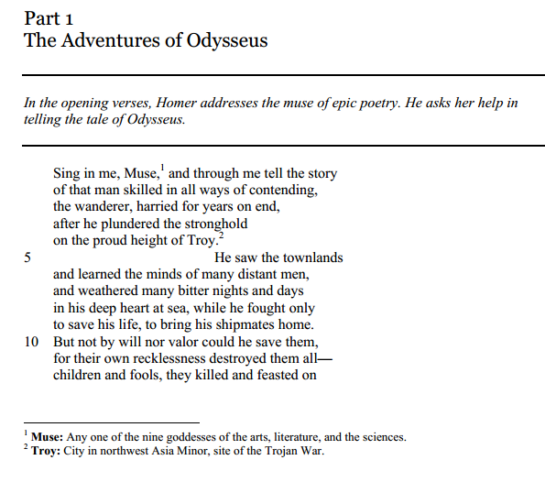
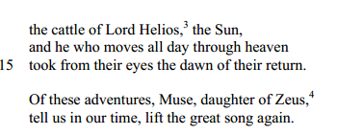
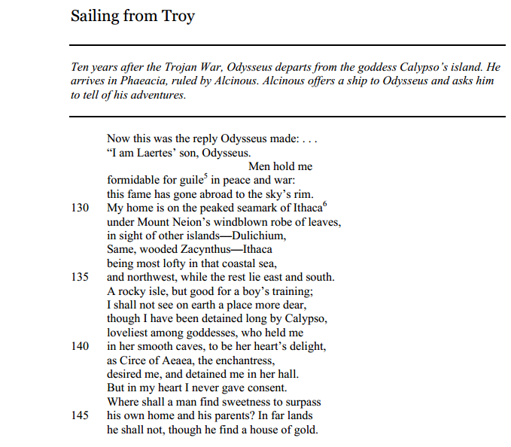
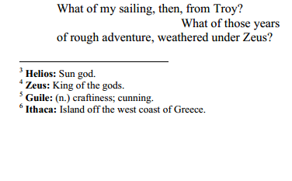
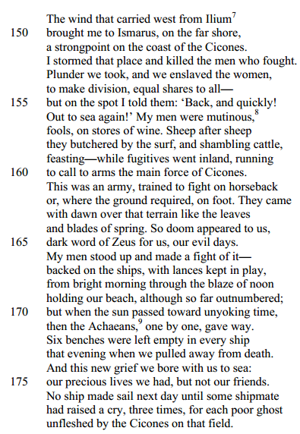

Station 3: The Characterization of Odysseus

In your group, read the first two versus from the epic poem, The Odyssey. Annotate the passages looking for characterization (direct and indirect) that helps you determine what type of man Odysseus is. Then, answer the questions below in complete answers.

Direct Characterization Chart- AUTHOR SAID

Characteristic of Odysseus | Evidence that supports your argument (word, phase or sentence and line #)
Wanderer, nomad | “he wandered, harried for years on end” ( 2).

Indirect Characterization Chart

Characteristic of Odysseus | Type  - what characters say (dialogue)  - what they do (action)  - what they think (interior monologue)  - what others say about them  - author uses syntax to reveal their traits | Evidence that supports your argument (word, phase or sentence and line #)
smart | What Odysseus says about himself (interior monologue) | “Men hold me formidable for guile in peace and war” (129).

